Player Bios:

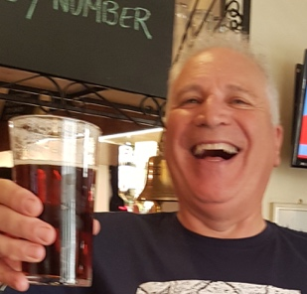**Name:** Richard Blake

**Nickname**: Blakey

**What’s In the bag** – Usually Ron’s clubs and rubbish

**Most memorable CRAP moment** – He is the founder, organiser and Godfather of CRAP ….oh and that remarkable scene at ‘the Karaoke’ night.

Blakey is the Softies captain and the founder of the ‘CRAP’ tours, hosting and planning tours both at home and abroad. He leads by example and is often getting warm weather training ahead of the Ryder Crap to hone his skills. He operates ‘Excalibur’ to ensure all the draws in the competition are fair. Without Blakey none of this would be possible, a true gent and jolly nice fellow, he also often saves us from being ‘plied with drinks’ in the Indian. A southerner at birth he follows Watford Football Club

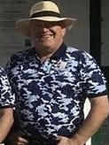**Name:** Ron Flowerday

**Nickname**: Ronnie

**What’s In the bag** – 8 iron, 5 iron, Wedge

**Most memorable CRAP moment** – Too many to mention i.e ‘Ronopoly’, Jocky McFlowerday, Seance, Reversible Bib, Biggles, anything involving Satelite Navigation.

Ron is Blakey’s closest confident and at one point held the esteemed role of ‘MC’ alongside Richard. Ron has had mixed luck on recent Ryder Cups being on the losing side as both a Northern and Southern player but is firmly back in favour amongst his fellow softies. Ron can often be found in the right hand semi rough. He supports Arsenal, Tottenham and various other teams.

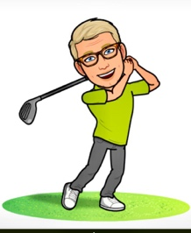**Name:** Paul Heath

**Nickname**: Porno

**What’s In the bag** – Allegedly a copy of Razzle

**Most memorable CRAP moment** –distributing illicit pictures

His nick name belies his behaviour and he refuted all knowledge of the ‘pictures’. Paul has been a regular on the CRAP circuit for a number of years and has picked up the order of merit trophy on a number of occasions. One of the lower handicap players on the tour he is a great opponent for the Gravy boys to take on, A lover of cars and all things ‘motor’ can often be found at ‘glorious Goodwood’. He takes a number of trips to the Northern training camp at PGC as a spy for Blakey, but is always warmly welcomed.

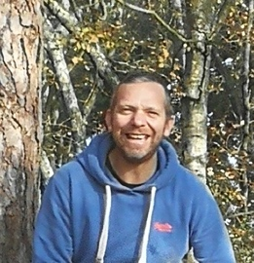**Name:** Adrian Heath

**Nickname**: Badger

**What’s In the bag** – ‘Who gives a fack’

**Most memorable CRAP moment** – involved a Bus and Window and a tongue

The Badger was an instant hit on his first year on tour in 2018, a true cockney who doesn’t know the word serious. The northerners didn’t really understand a lot of what he said but the fellow softies told us it was funny. He is definitely one to watch this year, a bit of practice prior to CRAP could see him as a force to be racooned with. A Portsmouth fan at heart so used to low expectations not being met.

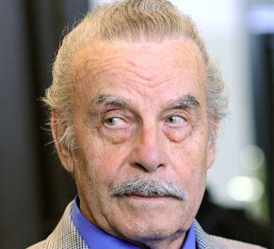**Name:** John Patching

**Nickname**: Patch

**What’s In the bag** – His remote control

**Most memorable CRAP moment** – Appearing in the Sun Newspaper

Patch is another long stay on the tour and always brings a wealth of experience. His skills on the course are varied but his putting ability is second to none. His remote controlled buggy is always good fun and Richard is a very big fan of the ‘drone trolley’ Often left within sight of the flag or just moving when anyone is about to play. It’s part of his game plan we know it and we love it.

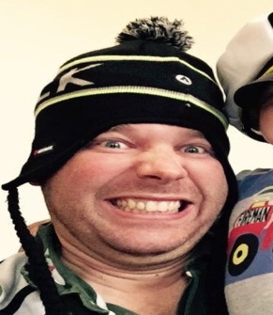

**Name:** James Blake

**Nickname**: Blakey junior

**What’s In the bag** – Rockets

**Most memorable CRAP moment** – Every single bloody drive (and most of his shots)

Blakey Junior is by far the best golfer on the CRAP circuit a low single figure player who is forced to start off 10 by his tyrannous father. Blakey junior is also the youngest player on the tour, the slimmest, best looking and probably also the richest. Always paired with his Dad on the Saturday Cornish Scramble they have yet to be beaten, I wonder if this will change this year (like the format did last year to help them!)

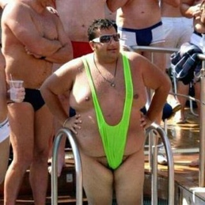**Name:** Tony Batchelor

**Nickname**: Batch

**What’s In the bag** – Probably Red Wine and ‘The Claw’

**Most memorable CRAP moment** – Involved a fruit basket and a broom (but no Germans)

Batch is the CRAP drinking champion, Cribbage contestant and one half of the chuckle brothers. Batch has won the illustrious ‘frisbee’ a number of times, but as the tour champion he plays this down. His greatest skill though seems to be off the course with alcohol quaffing. Brilliantly funny and a tour member since its very instigation. Batch is an avid Reading fan.

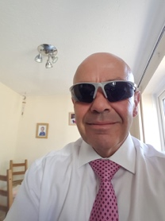**Name:** Duncan Sanders

**Nickname**: Spunky

**What’s In the bag** – Any 50p club he can get his hands on

**Most memorable CRAP moment** – Involved a direct hit on the Regulator

Spunky is the only CRAP player with sponsorship, his golf balls are sourced from an ‘acquaintance’ at Srixon. The other half of the Chuckle Brothers he is often found accompanying Batch in the bar or playing Cribbage against the Gravy Boys for the ‘Lee Westwood Two Down Trophy’. Co- creator of the innovative ‘iCrib 2’ system and many other brilliant Ryder Crap accessories. A real Chelski fan and true southerner.